E-STEM Middle School
600 Weir Drive
Woodbury, MN 55125
651-744-2900

CLASS NAME:
English Language Arts (Reader’s/Writer’s) 6

TEACHER NAME:
SAM SHOEMAKER

WHAT STUDENTS WILL LEARN IN MY CLASS:
This year students will be completing both the required reading and writing standards in one classroom. Students will be working with a variety of units throughout the year focusing both on reading and writing fiction and non-fiction (such as Fantasy/Dystopian, Argument, and Poetry).

Accompanying both reading and writing units, guided reading groups will take place throughout their ELA class. These groups will be based on your student’s individual needs after three separate tests over the course of the year.

Students will read or write independently every day! Our classroom has a variety of novels at many different reading levels. Students will have the opportunity to check out books from the classroom or the library. E-STEM expects that all students have an independent reading book with them at all times.

Each student will use a reader’s and writer’s response notebook in class to document their thought process and skill development. Please provide 2 composition notebooks by September 10th!

GRADING:
Student grades are based 80% on assessments (summative) and 20% on homework (work completed at home and in-class assignments).

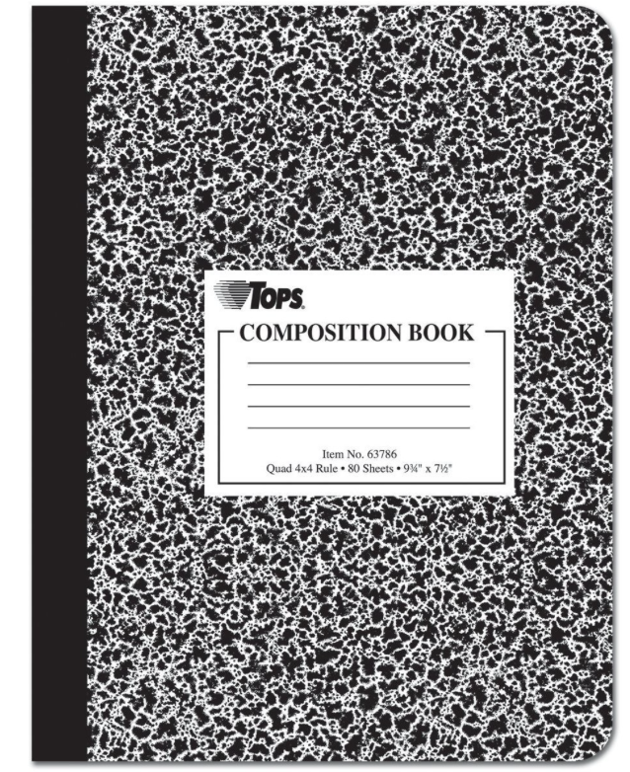
ASSSESSMENTS:
Students will have at least one summative assessment per unit.

MATERIALS NEEDED FOR ENGLISH 6:
- 2 composition notebooks
- Pencils and pens
- Independent reading book

HOMEWORK:
Among other small assignments, students are required to read 30 minutes a night or 210 minutes per week. Each Friday students will hand in a reading log (with guardian signature), and a one-page response to a journal prompt.

HOW TO CONTACT ME: Students and parents can contact me with any questions.
Direct phone: +
E-mail: sam.shoemaker@spps.org

Parent/Guardian Name: __________________________________________

Best Number to Reach You: __________________________________________

